***************** AMBARI_INSTALLATION ***************

************************************************************************************************************

CREATE 3 Virtual machine (1-cluster,2-node)

On all-machine:-

—---------------------

# set hostname

[root@localhost]# hostnamectl set-hostname cluster,node1,node2

#install enable and start httpd

yum install httpd -y

systemctl enable httpd.service

systemctl start httpd

systemctl status httpd

#set ip in host file like this

[root@silver-node1 ambari]# vi /etc/hosts

192.168.0.1 SILVER-NODE1

192.168.0.2 SILVER-NODE2

192.168.0.3 SILVER-NODE3

# Make sure all node ping to each other

On cluster:-

—---------------

#Create a directory in html file

cd /var/www/html/

mkdir ambari

#Copy ambari,hdp,& hdp-utils tar file in created path

# untar the file

tar -xvf ambari-2.7.3.0-centos7.tar.gz

#copy repo file in yum.repos.d path

cp /var/www/html/ambari/ambari/centos7/2.7.3.0-139/ambari.repo /etc/yum.repos.d/

# create repofile

createrepo ‘untar filename’

# Edit in ambari.repo file(writ e ambari file path in baseurl)

vi /etc/yum.repos.d/ambari.repo

VERSION_NUMBER=2.7.3.0-139

[ambari-2.7.3.0]

#json.url = <http://public-repo-1.hortonworks.com/HDP/hdp_urlinfo.json>

name=ambari Version - ambari-2.7.3.0

**baseurl=**[**http://cluster/ambari/ambari/centos7/2.7.3.0-139**](http://cluster/ambari/ambari/centos7/2.7.3.0-139)

**gpgcheck=0**

**#gpgkey=**[**http://public-repo-1.hortonworks.com/ambari/centos7/2.x/updates/2.7.3.0/RPM-GPG-KEY/RPM-GPG-KEY-Jenkins**](http://public-repo-1.hortonworks.com/ambari/centos7/2.x/updates/2.7.3.0/RPM-GPG-KEY/RPM-GPG-KEY-Jenkins)

enabled=1

priority=1

# Do same as above in hdp.repo file (here edit hdp path and hdp-utils path)

[root@silver-node1 yum.repos.d]# vi /etc/yum.repos.d/hdp.repo

#VERSION_NUMBER=3.1.0.0-78

[HDP-3.1.0.0]

name=HDP Version - HDP-3.1.0.0

baseurl=<http://cluster/hdp/HDP/centos7/3.1.0.0-78>

gpgcheck=0

#gpgkey=<http://public-repo-1.hortonworks.com/HDP/centos7/3.x/updates/3.1.0.0/RPM-GPG-KEY/RPM-GPG-KEY-Jenkins>

enabled=1

priority=1

[HDP-UTILS-1.1.0.22]

name=HDP-UTILS Version - HDP-UTILS-1.1.0.22

baseurl=<http://cluster/hdp-utils/HDP-UTILS/centos7/1.1.0.22>

gpgcheck=0

#gpgkey=<http://public-repo-1.hortonworks.com/HDP/centos7/3.x/updates/3.1.0.0/RPM-GPG-KEY/RPM-GPG-KEY-Jenkins>

enabled=1

priority=1

#check repolist

[root@cluster~]#yum repolist

repo id repo name status

HDP-3.1.0.0 HDP Version - HDP-3.1.0.0 201

HDP-UTILS-1.1.0.22 HDP-UTILS Version - HDP-UTILS-1.1.0.22 16

ambari-2.7.3.0 ambari Version - ambari-2.7.3.0 13

base/7/x86_64 CentOS-7 - Base 10,072

extras/7/x86_64 CentOS-7 - Extras 515

updates/7/x86_64 CentOS-7 - Updates 4,538

repolist: 15,355

# Copy ambari.repo file on other both node in same path

rsync /etc/yum.repos.d/ambari.repo root@node1:/etc/yum.repos.d/ambari.repo

rsync /etc/yum.repos.d/ambari.repo root@node2:/etc/yum.repos.d/ambari.repo

#install,setup,start&check status ambari-server

yum install ambari-sever

ambari-server setup -s

ambari-server start

ambari-server status

# Install start and check status ambari-agent ("install on all machine")

yum install -y ambari-agent

ambari-agent start

ambari-agent status

# Edit this file(Write in hostname=’cluster hostname’ on all machine )

[root@silver-node1 ambari]# vi /etc/ambari-agent/conf/ambari-agent.ini

# Licensed to the Apache Software Foundation (ASF) under one or more

# contributor license agreements. See the NOTICE file distributed with

# this work for additional information regarding copyright ownership.

# The ASF licenses this file to You under the Apache License, Version 2.0

# (the "License"); you may not use this file except in compliance with

# the License. You may obtain a copy of the License at

#

# <http://www.apache.org/licenses/LICENSE-2.0>

#

# Unless required by applicable law or agreed to in writing, software

# distributed under the License is distributed on an "AS IS" BASIS,

# WITHOUT WARRANTIES OR CONDITIONS OF ANY KIND, either express or implied.

# See the License for the specific

[server]

hostname=cluster

url_port=8440

secured_url_port=8441

connect_retry_delay=10

max_reconnect_retry_delay=30

[agent]

logdir=/var/log/ambari-agent

piddir=/var/run/ambari-agent

prefix=/var/lib/ambari-agent/data

;loglevel=(DEBUG/INFO)

loglevel=INFO

data_cleanup_interval=86400

data_cleanup_max_age=2592000

data_cleanup_max_size_MB = 100

ping_port=8670

cache_dir=/var/lib/ambari-agent/cache

tolerate_download_failures=true

run_as_user=root

parallel_execution=0

; 0 - don't report commands output periodically. Reduces bandwidth on big cluster

command_update_output=1

alert_reports_interval=5

command_reports_interval=5

status_commands_run_interval=20

alert_grace_period=5

# restart all services (httpd,ambari-server,amabri-agent,)

# stop firewall

#Go to browser and type:-cluster:8080/#/login

Id-admin

Password-admin

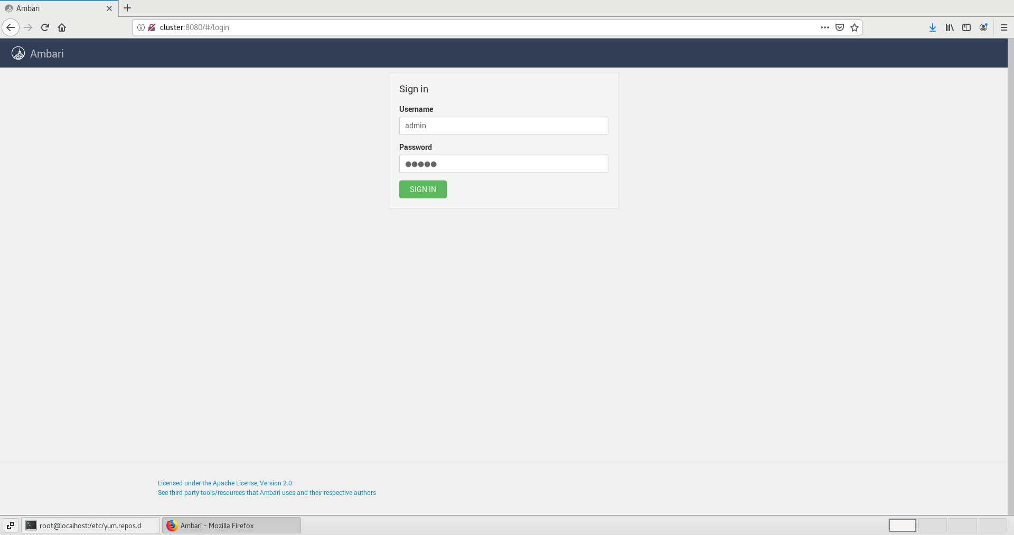

# Write name as u want and click next

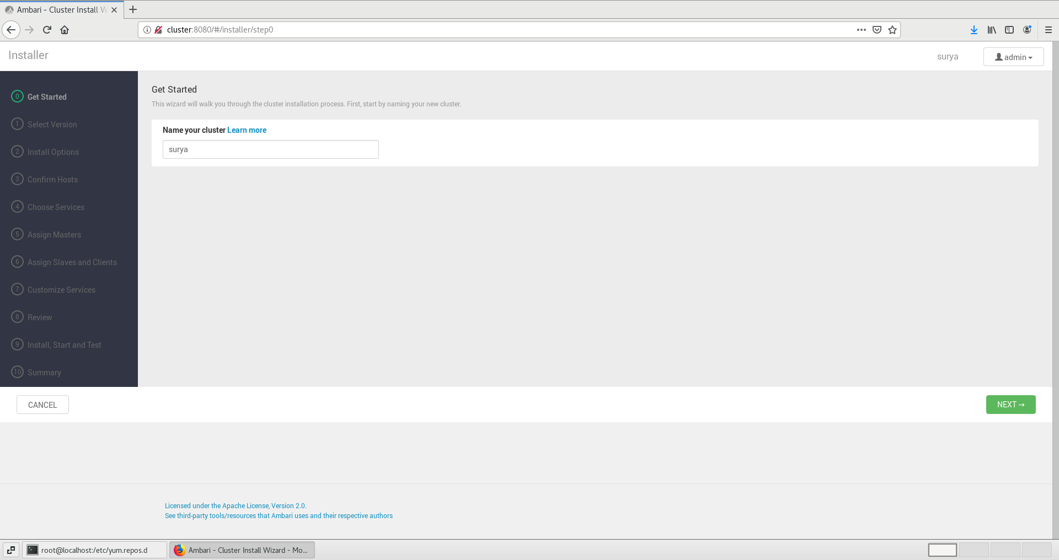

#Copy and paste hdp and hdp-utils path from hdp.repo file and click next

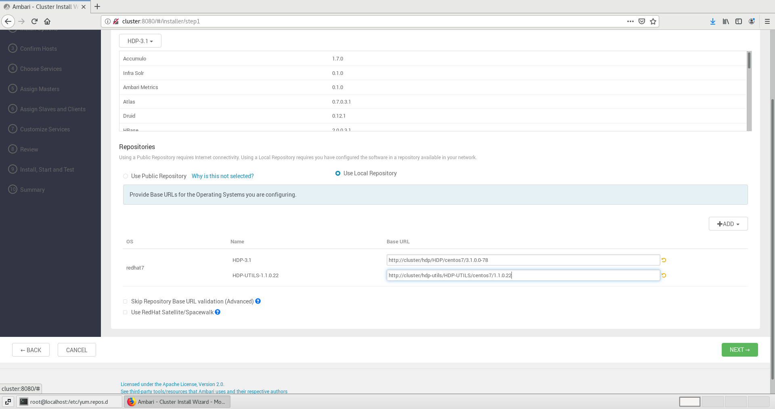

# Write your cluster and nodes name and click next

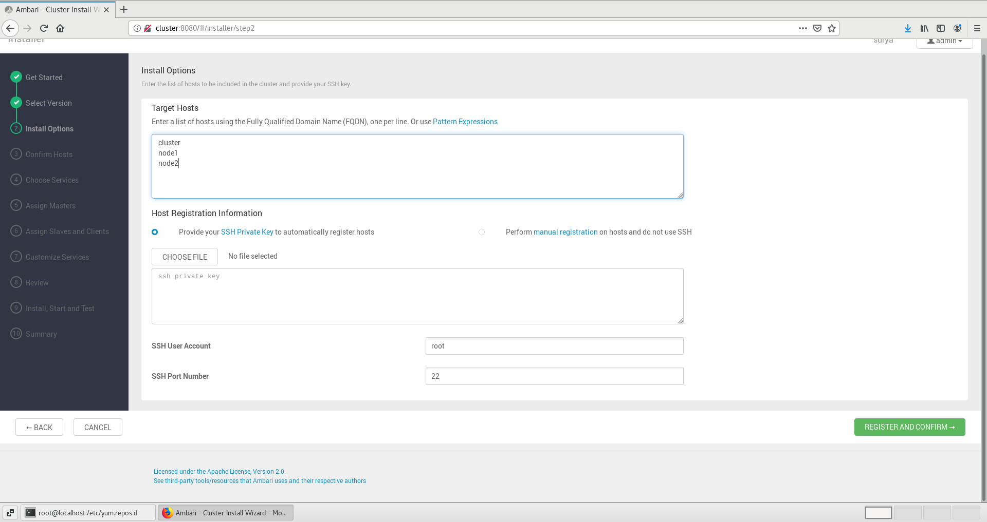

# click next

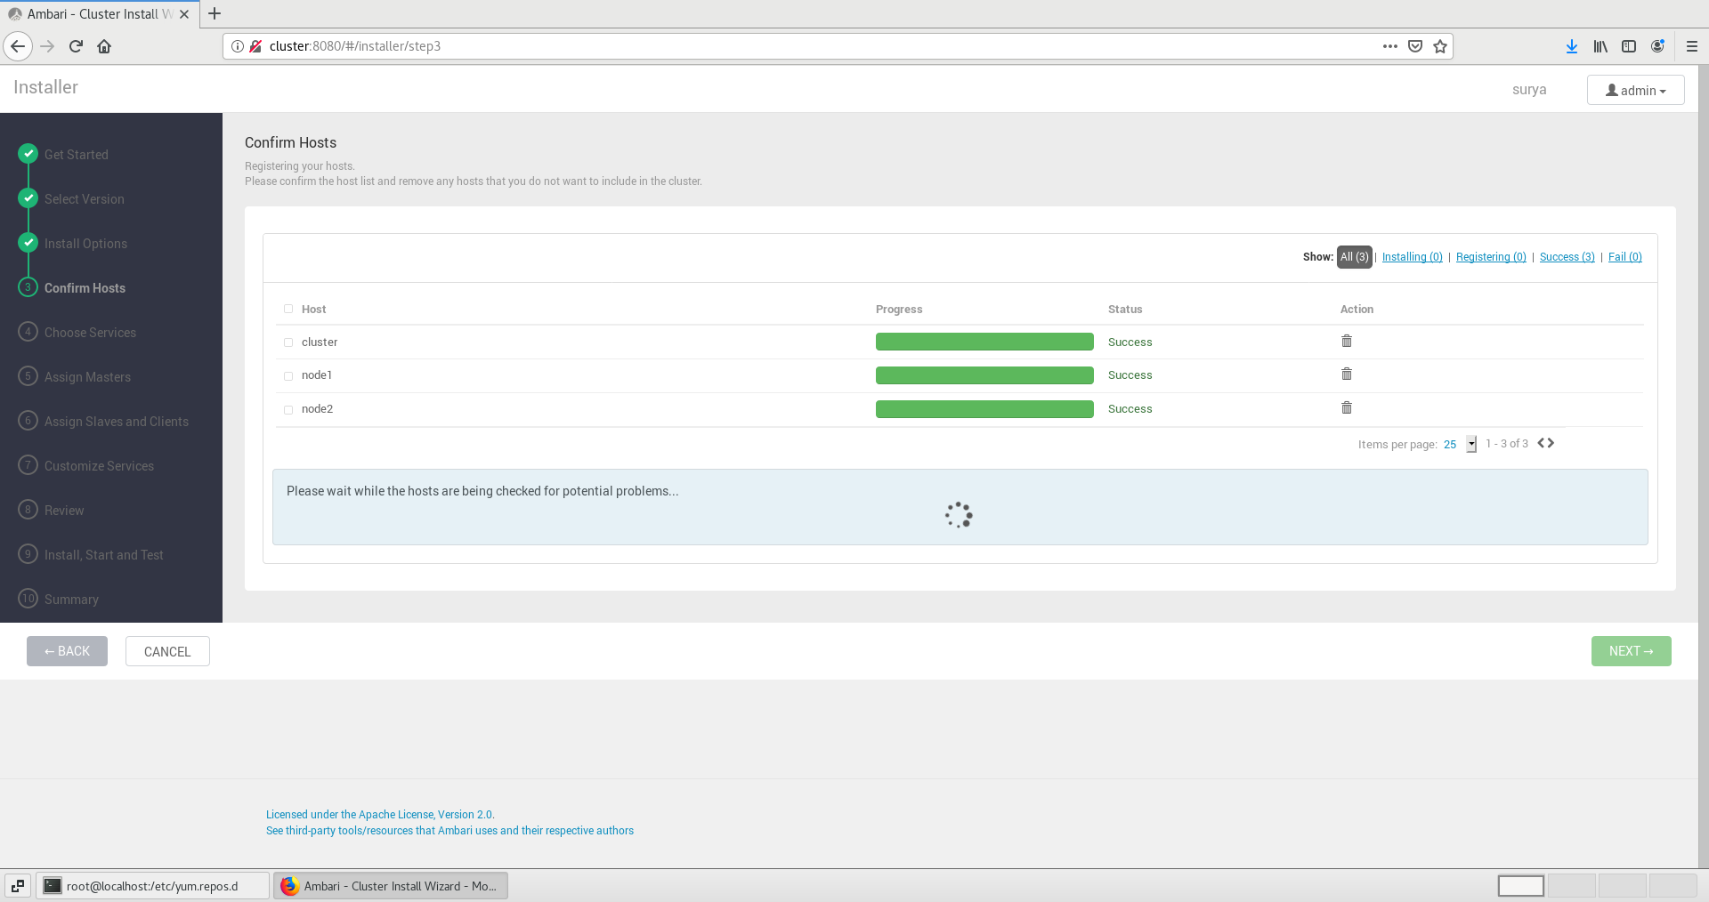

# Selct as given below

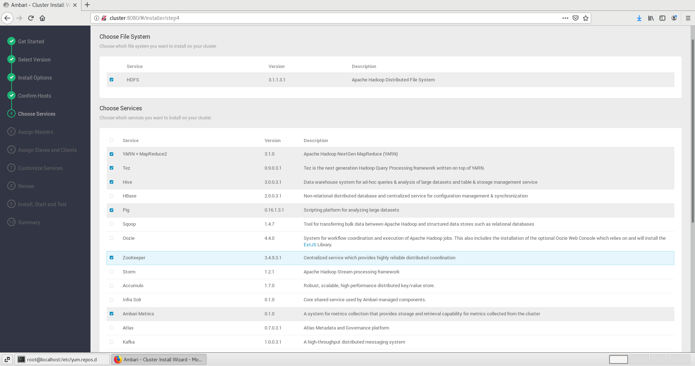

# Click next

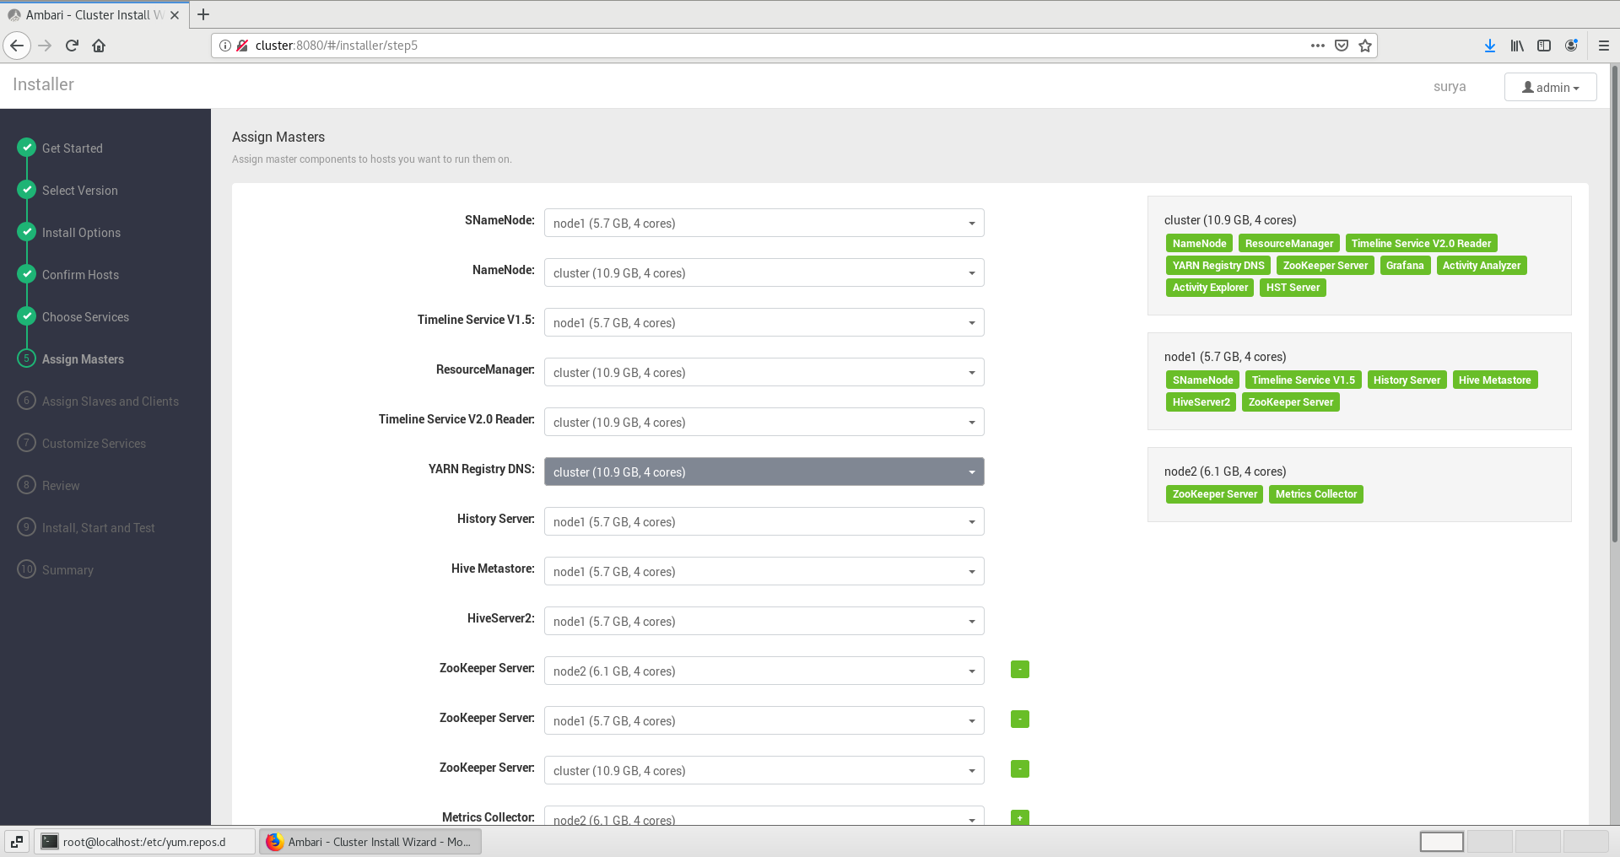

# Check tick as following

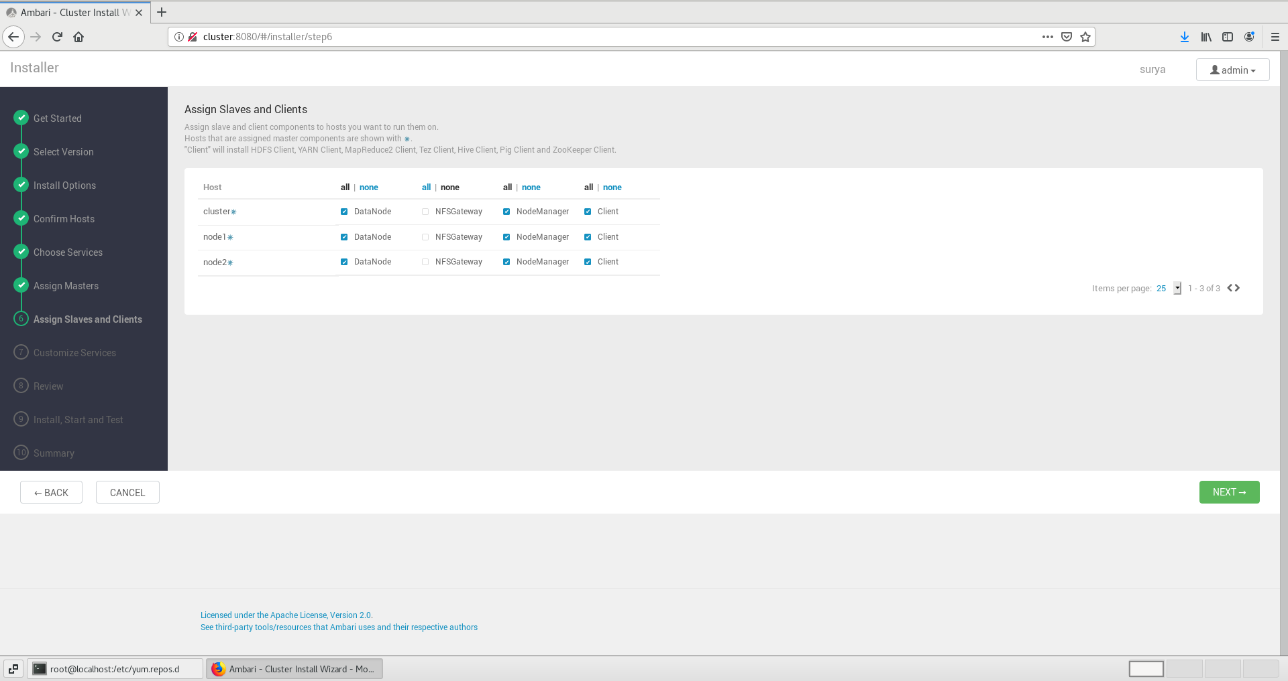

# Enter pasword and click next

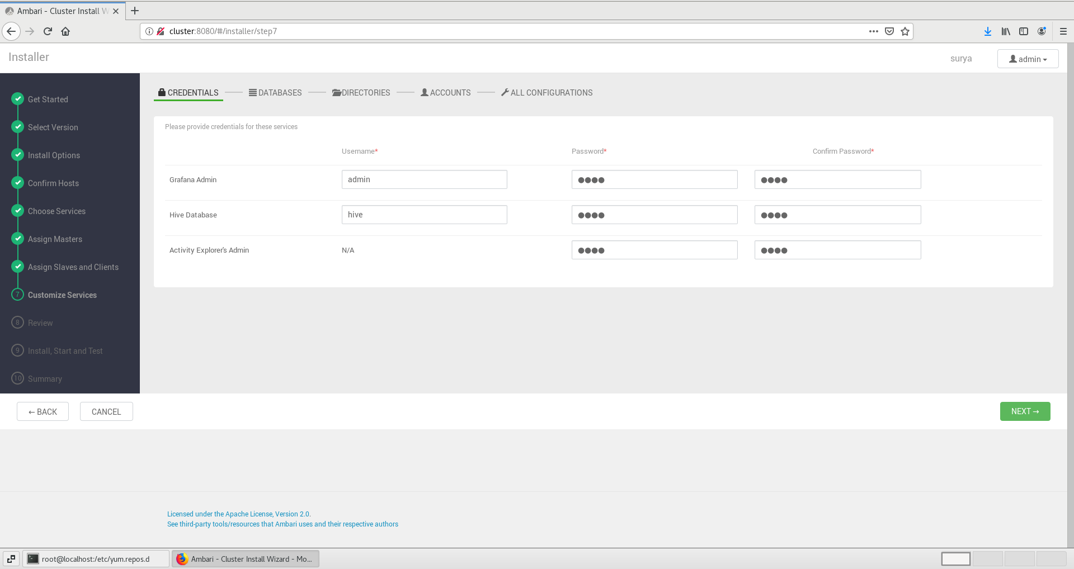

#click on link

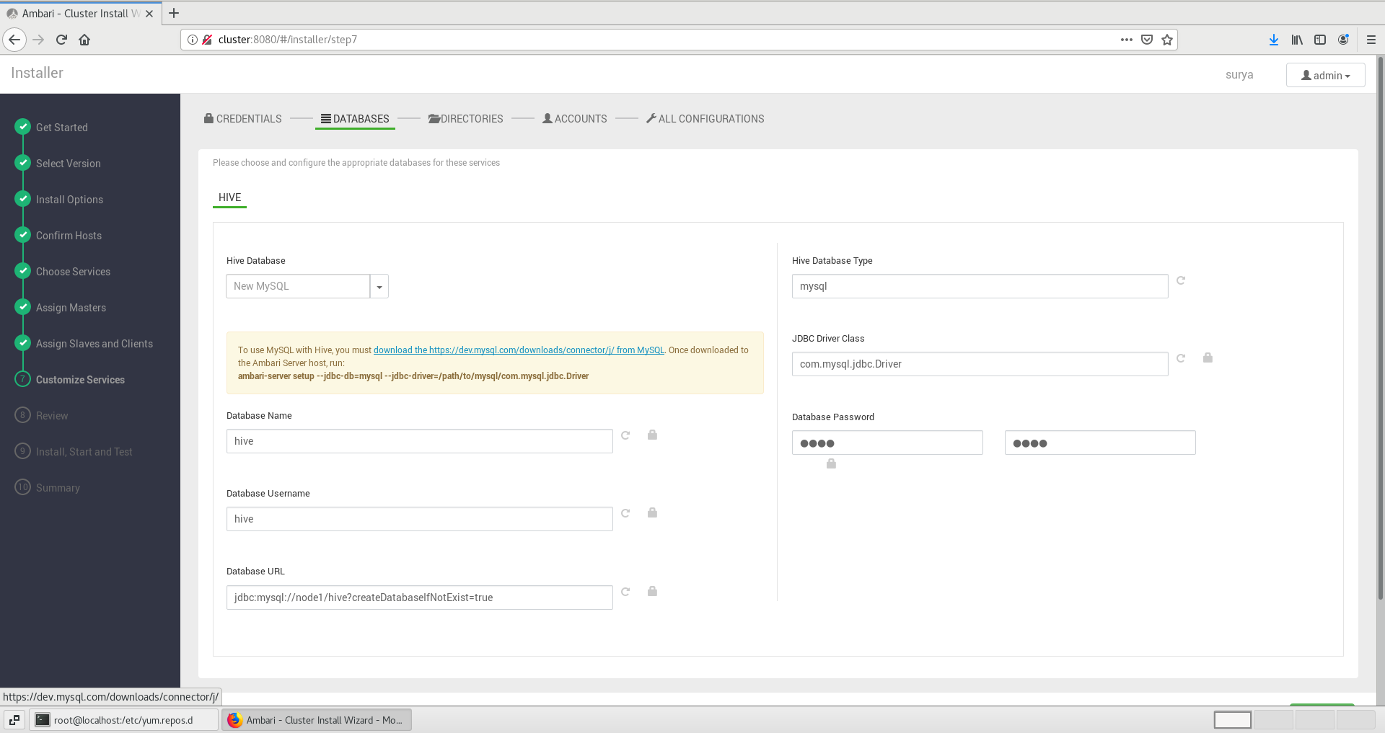

# select your OS and their version

# Click on download

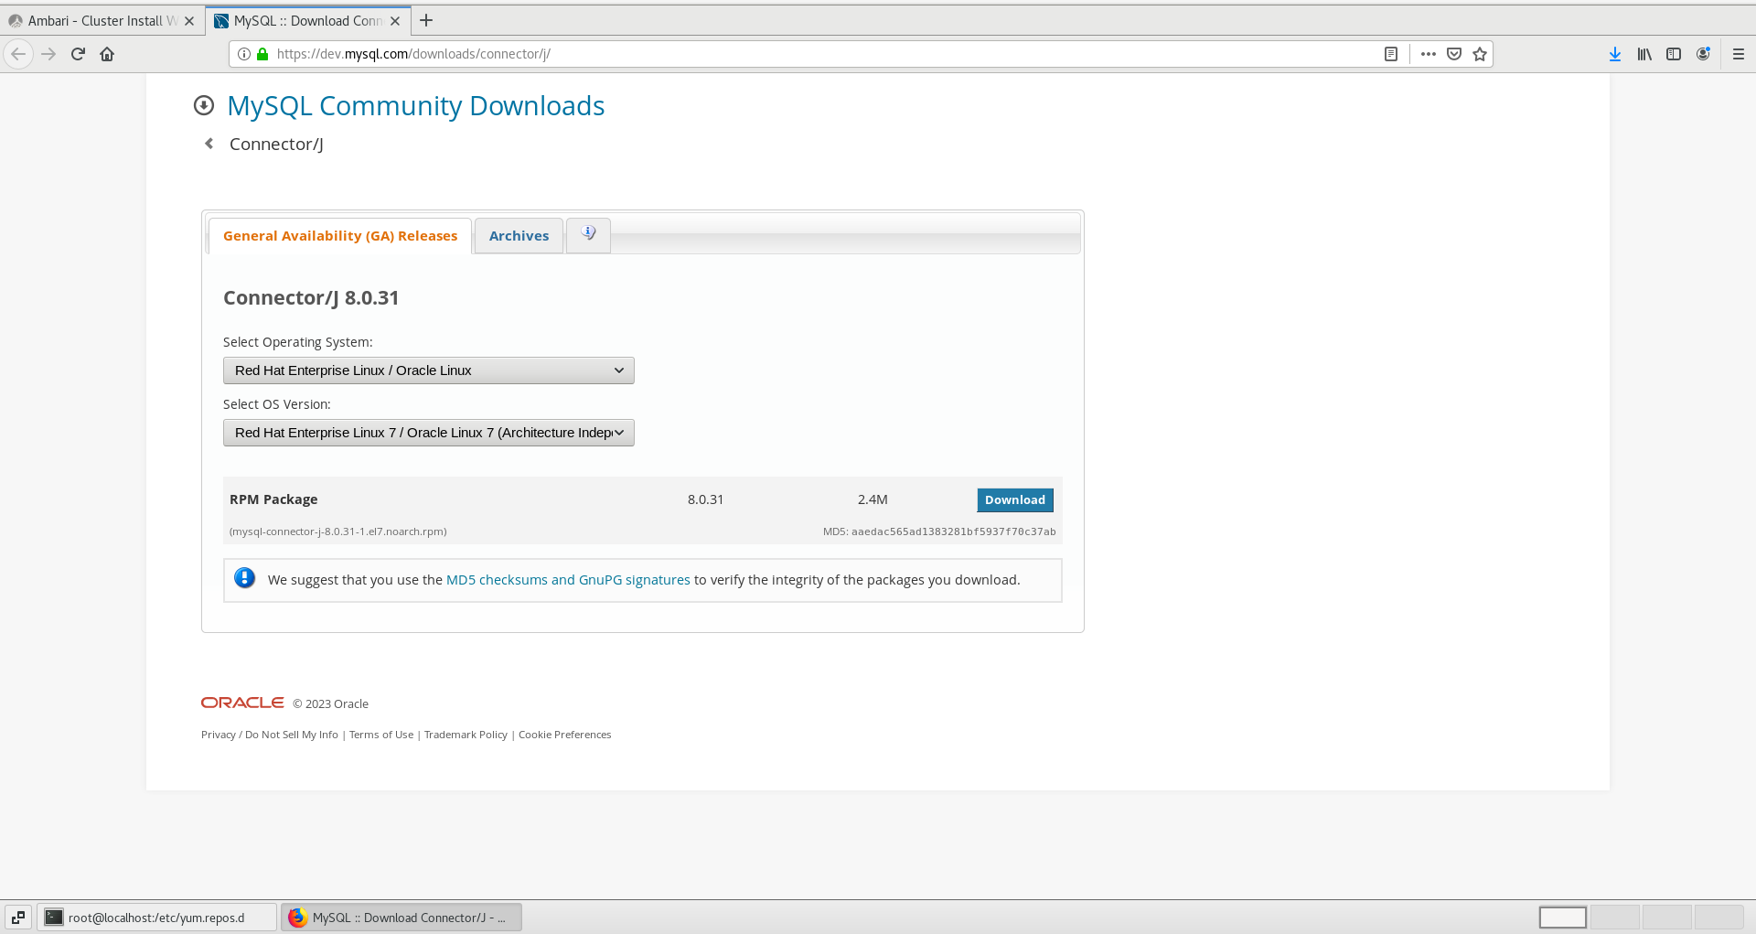

# Click on ‘no thanks just want to Download’

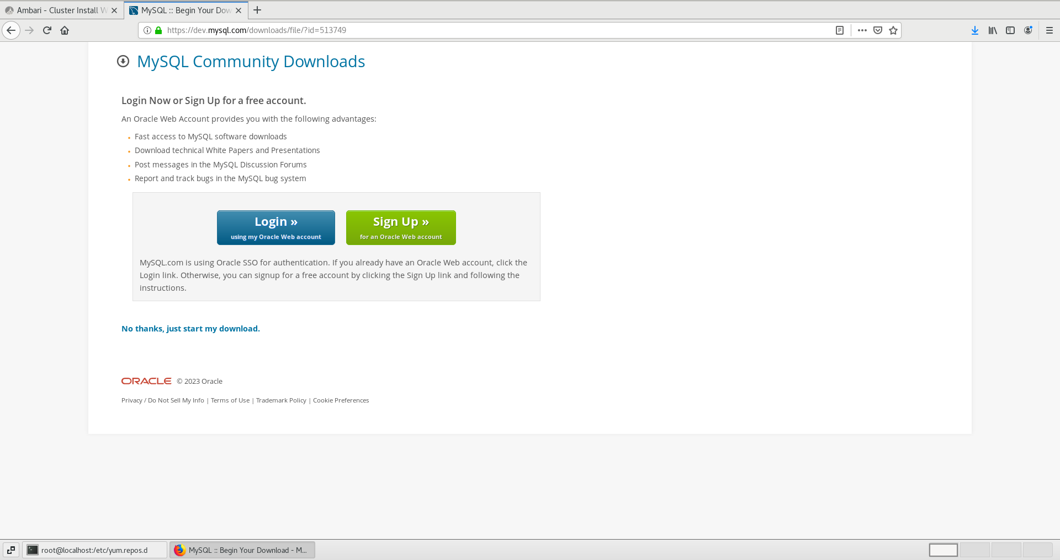

On terminal

rpm -ivh /root/Downloads/mysql-connector-j-8.0.31-1.el7.noarch.rpm

Cd /usr/share/java/

Ambari-server setup –jdbc-db=mysql –jdbc-driver=/usr/share/java/mysql-connector-j.jar

# Click on next

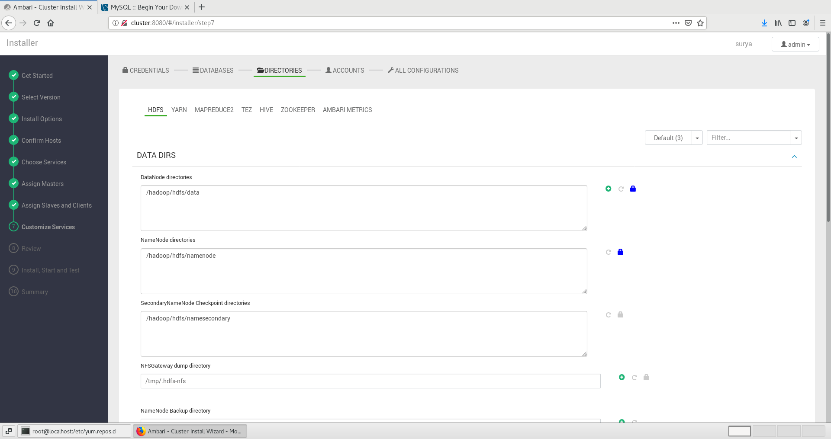

# Click on next

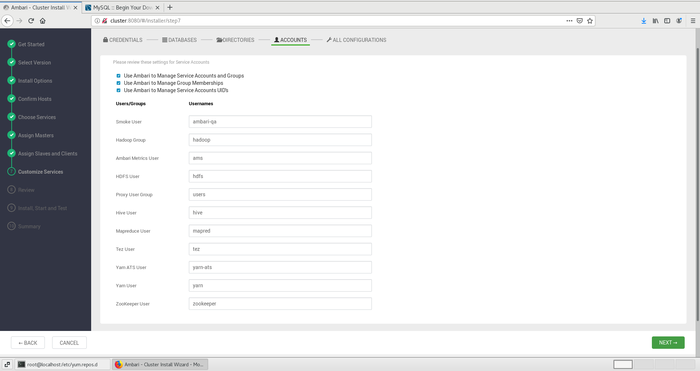

# Click ‘Next’

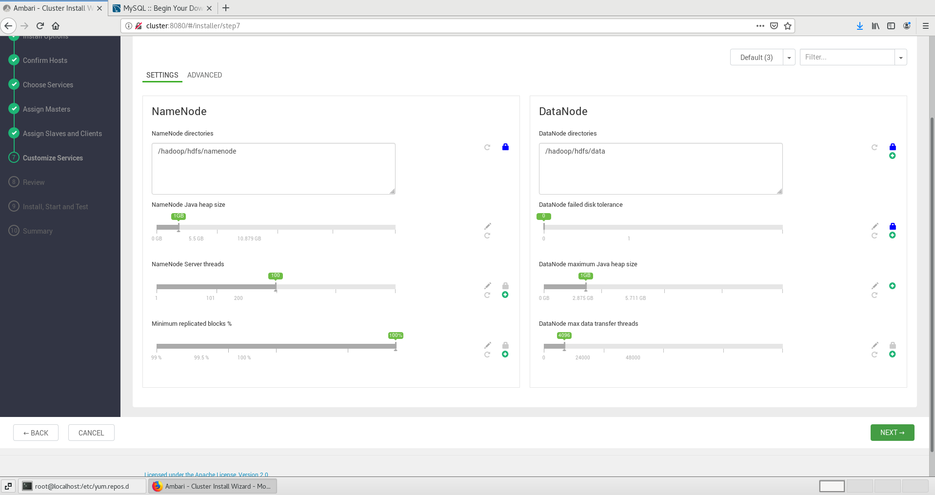

Open this URL:-<https://www.cnblogs.com/nshuai/p/13404273.html>

‘or’

Follow below rule

find out the line(39892) : onNetworkIssuesExist: function () {

Change the line from :

/**

* Use Local Repo if some network issues exist

*/

onNetworkIssuesExist: function () {

if (this.get('networkIssuesExist')) {

this.get('content.stacks').forEach(function (stack) {

stack.setProperties({

usePublicRepo: false,

useLocalRepo: true

});

stack.cleanReposBaseUrls();

});

}

}.observes('networkIssuesExist'),

—----------------------------------------------------------------------------------------------------------

On terminal;

cd /usr/lib/ambari-server/web/javascripts/

vi app.js

# After configuration click on deploy

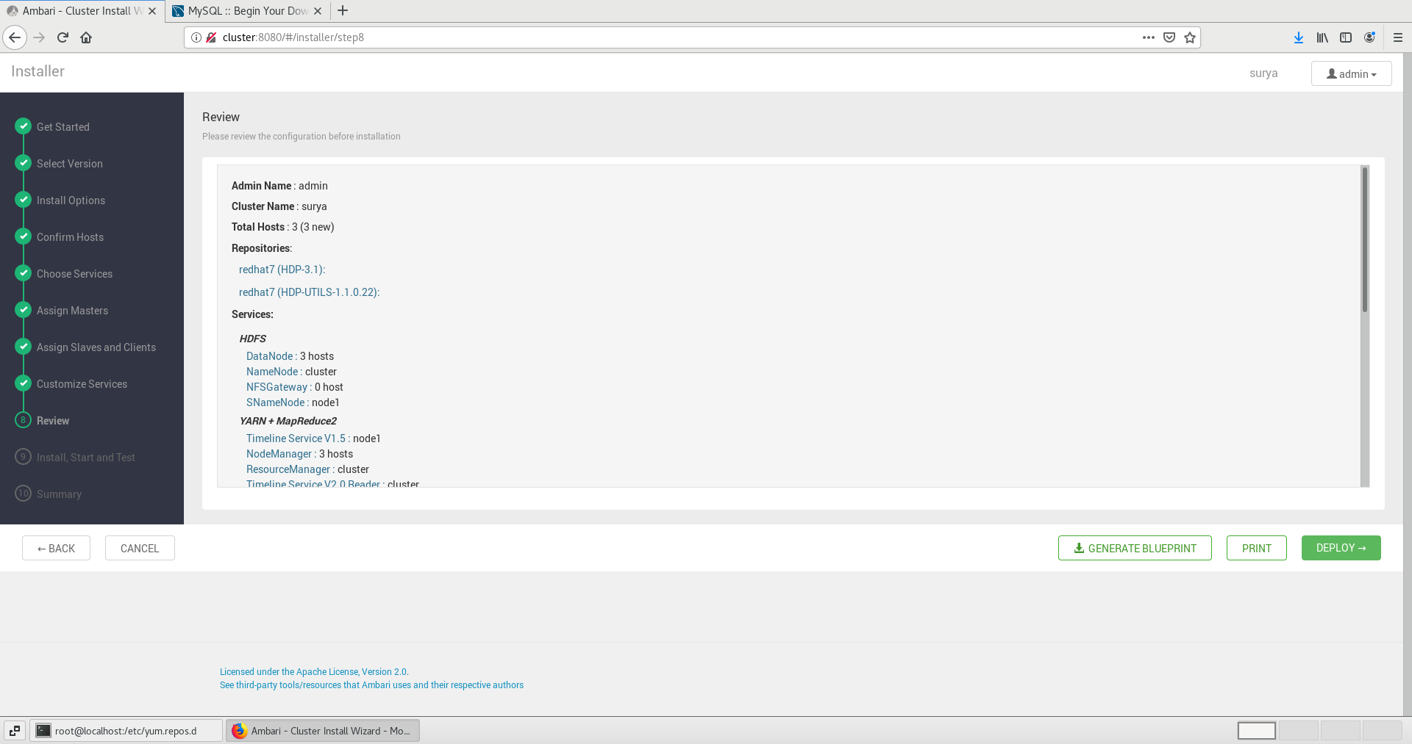

# Click next

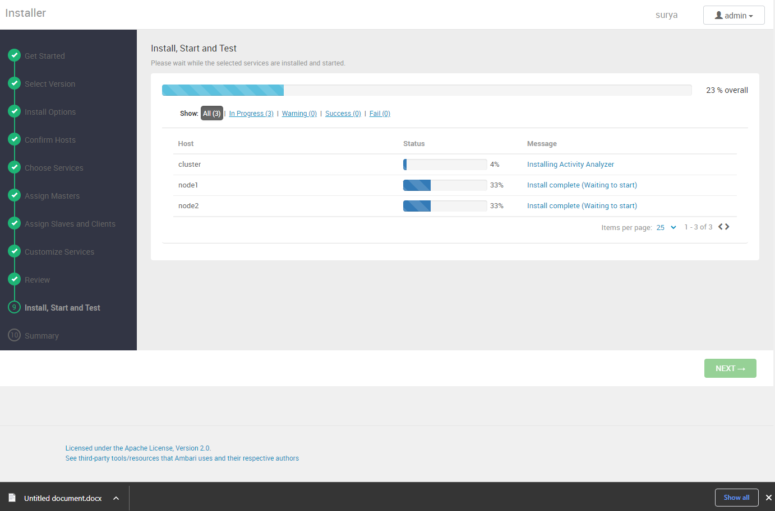

# Ambari Dashboard

